

**Small Successes**

**Large Rewards**

**Speaker – Adeena Niazi**

**Founder of Afghan Women’s Organization**

**Sunday, November 18, 2018 6:00pm**

**Doors open at 5:15 pm**

**silent auction, Afghan needlework and displays**

**St John’s Anglican Church – 99 Brock Street**

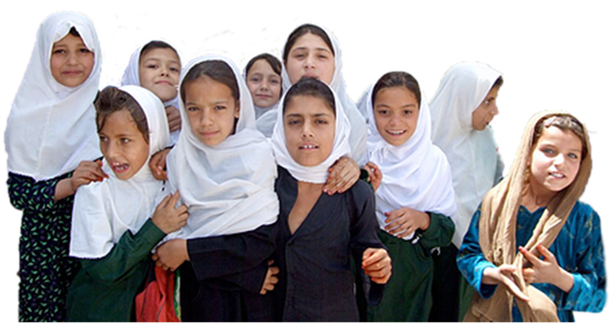

**St. John’s Anglican Church**

**99 Brock Street**

**Featuring the tastes and sounds of Afghanistan**

**Proceeds from the evening will go to CW4WAfghan to further the education of women & girls in Afghanistan**

**Tickets: $30 or $20 unwaged/students**

Contact Daphne at (705) 656-3820 for more information or

**Peterborough@CW4WAfghan.ca**